Homework 10
Name
Institutional Affiliation

Question 1
The GDP measures total production of an economy within it borders. Therefore, some items that do not ass up to the economy total productions are excluded from the GDP.
- South Carolina is within the geographical boundaries of the US therefore; the van factory production will count towards the US GDP.
- When calculating GDP, we add exports (good produced within the country) and deduct imports (good produced outside the country). Buying a Samsung phone from South Korea is an import therefore counted in the US GDP when calculating net exports.
- Under the US GDP, small individualized services such as helping with minor house chores and babysitting for family members even though at times paid are not included in the national GDP.
- Foreign direct investment (FDI) withing an economy affects GDP, when done outside economy it is not counted in GDP. The building of the factory in Mexico is and FDI outside US economy therefore not counted in US GDP.
- Buying bread from local bakery is part of consumption expenditure and it is counted in the GDP.
- The 20 units that were produced in 2019 by Chrysler in Utah but not sold are deemed as inventory that is purchased by manufacturer. Inventory is component of GDP and therefore counted.
- Final services which are included in GDP are those rendered at a price. The free tax services fail to meet criteria and therefore not counted in GDP computation.
Question 2

Table: Gadget GDP in Apriland
2019 Population of Apriland =12,000
2018 Gadget Prices (base year) = $500
2018 Population of Apriland =10,000
2019 Gadget Production = 4,400
2019 Gadget Prices =$600
2018 Gadget Production =$4,000

- 2018 & 2019 Nominal GDP
The nominal GDP is the total market value of goods and services produced within the economy that is not adjusted for inflation.
Give the information on the table above;
2018 Nominal GDP = 2018 Gadget Prices (base year) * 2018 Gadget Production
= $500 * $4,000
= $2,000,000
2019 Nominal GDP = 2019 Gadget Prices * 2019 Gadget Production
= $600* $4400
= $ 2,640,000
- 2018 & 2019 Real GDP
In 2018 = Gadget Prices (base year) * 2018 Gadget Production
= $500 * $4,000
= $2,000,000
In 2019 = Gadget Prices (base year) * 2019 Gadget Production
= 500*4400
= $2,200,000
- Growth rate = (Value ending – Value beginning) / Value beginning

= ($2,200,000 - $2,000,000)/ 2,000,000 *100%
= 10%
There is an economic growth in Apriland
- To know if there is improvement in standards of living, we calculate the Per capita income.

The per capita income = (Real GDP / population)

2018 per capita = ($2,000,000/ 10000) = $200
2019 per capita = ($2,200,000/ 12000) = $183.33
From the calculation it is clear that there way a decrease in standard of living because the per capita decrease in 209 compared to 2018.

Question 3
- Cupcake price index
Cost of basket per year
2017 = (4*1.10 + 1*1.10 +2*1.25) = $8
2018 = (4*1.15 + 1*1.10 +2*1.45) = $8.6
2019 = (4*1.25 + 1*1.20 +2*1.50) = $9.2
Consumer price index = (cost of basket current year/ cost of basket base year) * 100%
CPI 2017= ($8/$8) *100 = 100
CPI 2018 = ($8.6/$8) * 100 = 107.5
CPI 2019 = ($9.2/$8) * 100 =115
- Inflation is calculated by subtracting the CPI of different years to determine rise or fall in inflation.
Between 2018 & 2017 = ($107.5-$100)/100 = 7.5% inflation
Between 2019 & 2018 = ($115-$107.5)/107.5 = 6.98% inflation
Between 2019 & 2017 = ($115-$100)/100 = 15% inflation

Question 4
The four scenarios are different and therefore Lin will face a differ job market condition.
- There is a lay of because of a minor recession, Lin and other staff are assured to get back their job once recession ends. Lin is willing to continue working and therefore the kind of unemployment Lin faces is Cynical unemployment. It occurs with recession and when market conditions improve the workers get back their jobs.
- When the large university which is the main employer shuts down, the owner of the salon is forced to close on weekdays and only operate on weekend because of fewer customers. Therefore, Lin is laid off because of demand deficit unemployment. It occurs when the demand is not sufficient to sustain employees of the business.
- Lin seems dissatisfied with her current job at the salon and therefore quits and is willing and looking for employment in other salons where she is qualified to work. In this case Lin is experiencing frictional unemployment as she is facing short term unemployment as she looks for better employment.
- When Lin quits working and decide to joining college to pursue a B.A course in biology she is experiencing voluntary unemployment. Voluntary unemployment is when one is unemployed voluntarily when there is a job in the market that fits qualification but the person is not willing to take the job.
Question 5
- The real interest that Eddy is expected to pay to the bank is the rate that the bank offers after allowing for inflation. Therefore, it will be the difference between the nominal rate (rate unadjusted for inflation) and the inflation rate (adjustment).
Given nominal rate = 6%, inflation rate =3%,
Real interest rate = (6-3) = 3%
- When the real inflation is higher than the forecasted inflation by the bank in the loan period, Eddy will not be hurt. The real inflation is higher than expected inflation meaning that the bank will be hurt rather than Eddy because the real interest rate will be lower.
- When the real inflation is lower than the forecasted inflation by the bank in the loan period, Eddy will be hurt. The real interest rates will be higher with the decrease in inflation rates and therefore the bank will charge more interest from Eddy.
Question 6
The government is expected to have a deficit because of the decrease in amount of taxes collected because of the current pandemic. Because of lower levels taxation it means that the citizens will have a higher disposable income. The higher disposable income gives them more freedom to spend on commodities and services. Assuming that there will be a higher consumption, the effect of the deficit on net interest rates and investment will be as follows;
With there is government deficit there is need for borrowing and the government borrows from the banks to suffice the deficit. Borrowing from the banks leads to low money supply available for lending to individuals and business. Thus, the money supply in the market shift to the left. The interest rates also increase with the decrease of money available to loan by the banks. The effect occurs because Aggregate demand (AD) = Consumption (C) + Investment (I) + Government Spending (G) + Exports (X) – Imports (M). the result is the shift of the market equilibrium to the left.
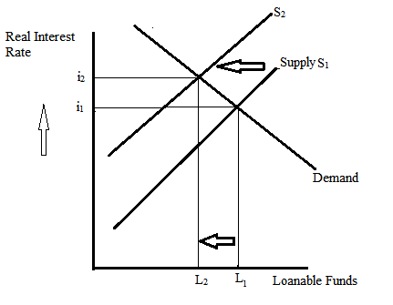
The supply shift to the left to S2 and interest increases to i2 while loanable funds decrease to L2.
b)
When there is recession, the government will respond by increasing money supply in the economy through increased government spending and also through lowering the federal reserve rate. The effect of this will be a shift of the supply curve to the left and decrease in interest rates for the loanable funds. Because of decrease in interest rates the aggregate demand for money will increase as indicated in the graph below.
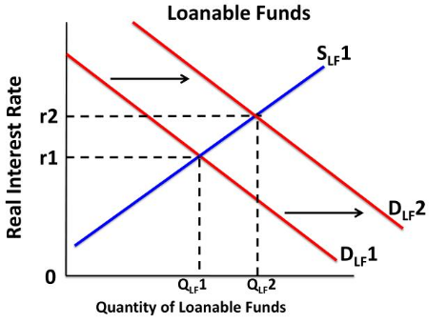
The quantity of loanable funds increases and demand increases.
Question 7

The labor participation rate is the rate of the total citizens of an economy that are in the labor force. The unemployment is the rate of persons willing to work at the current market prices and having qualified for jobs but lack employment. When the labor participation rate decreases it means that there is lower labor force compared to previous time therefore meaning that there would be lower unemployment. Therefore, the scenario of simultaneous decrease in participation and unemployment rates is not a common phenomenon. It is unlikely to occur in any market because when labor participation force declines it is expected that unemployment declines and not increase.

Economics may be right because although the simultaneous decline in both labor participation and unemployment is uncommon, in real word it happened in the US economy. High rate of voluntary employment may cause the phenomenon to occur but it is very unpredicted in economics because there is assumption that employees are rational.
c)
The labor participation rate is the most relied upon tool in measuring unemployment because it takes the consideration of whole economy. Other measures look into the current employee only and fail to consider the labor market as a whole.

